Assignment 2: Hybrid Retrieval-Augmented Generation (RAG) System with Automated Evaluation

Course: Conversational AI
Assignment: 2
Submission Date: 8 February 2026

Group Number: 149

Group Members:
- Priyansh Agrawal (2024aa05558) – 100%
- Arjun NV (2024aa05529) – 100%
- Ashwani Kumar Jaiswal (2024aa05155) – 100%
- Ananya Sharma (2024aa05306) – 100%
- Aarya Raikar (2024aa05190) – 100%

Git Repository link: https://github.com/AshwaniJaiswalIt/CAI_RAG/tree/main

Abstract
Retrieval-Augmented Generation (RAG) systems enhance large language models by grounding responses in external knowledge sources. In this assignment, we design and implement a Hybrid RAG system that combines dense vector retrieval, sparse keyword-based retrieval using BM25, and Reciprocal Rank Fusion (RRF) to answer user queries over a dynamically constructed corpus of 500 Wikipedia articles.

Our system integrates semantic and lexical retrieval signals to improve robustness across diverse question types. An automated evaluation framework is developed using 100 generated question–answer pairs, assessing retrieval effectiveness at the URL level through Mean Reciprocal Rank (MRR), along with additional custom metrics for answer quality and retrieval relevance. We further conduct innovative evaluations including adversarial testing, ablation studies, and detailed error analysis.

Experimental results demonstrate that the hybrid retrieval approach consistently outperforms dense-only and sparse-only baselines. The evaluation pipeline is fully automated, generating structured reports and visualizations, ensuring reproducibility and scalability.

1. Introduction
Large Language Models (LLMs) exhibit strong generative capabilities but are prone to hallucinations and knowledge limitations when used in isolation. Retrieval-Augmented Generation (RAG) mitigates these issues by augmenting generation with relevant external documents.

However, relying solely on dense semantic retrieval or sparse keyword-based retrieval introduces limitations. Dense retrieval may miss exact keyword matches, while sparse retrieval struggles with semantic paraphrasing. To address this, we propose a Hybrid RAG system that combines both approaches using Reciprocal Rank Fusion (RRF), leveraging complementary strengths.

In addition to system construction, robust evaluation is critical for understanding real-world performance. Therefore, we design an automated evaluation framework using generated questions, URL-level metrics, custom performance indicators, and innovative evaluation techniques.

2. Dataset Construction
2.1 Wikipedia URL Collection
The corpus consists of 500 Wikipedia articles per indexing run, divided into:
- Fixed Set: 200 Wikipedia URLs selected once and stored in fixed_urls.json. These URLs remain constant across all indexing operations and are unique to our group.
- Random Set: 300 Wikipedia URLs sampled randomly during each indexing run, ensuring variability in the corpus.

Each Wikipedia page contains a minimum of 200 words and spans diverse domains including science, history, geography, technology, and culture.

2.2 Text Extraction and Preprocessing

For each URL, the raw HTML content is fetched and cleaned using BeautifulSoup. Non-informative elements such as tables, references, and navigation text are removed. The remaining text is normalized by lowercasing and whitespace cleanup.
2.3 Chunking Strategy
The cleaned text is split into overlapping chunks of 200–400 tokens with a 50-token overlap. This strategy balances contextual completeness and retrieval granularity. Each chunk is stored with metadata including:
- URL
- Page title
- Chunk ID

3. System Architecture
The overall architecture of the Hybrid RAG system is illustrated in Figure 1. The pipeline consists of four main components:
1. Data ingestion and preprocessing
2. Hybrid retrieval (dense + sparse + RRF)
3. Response generation using an LLM
4. Automated evaluation framework
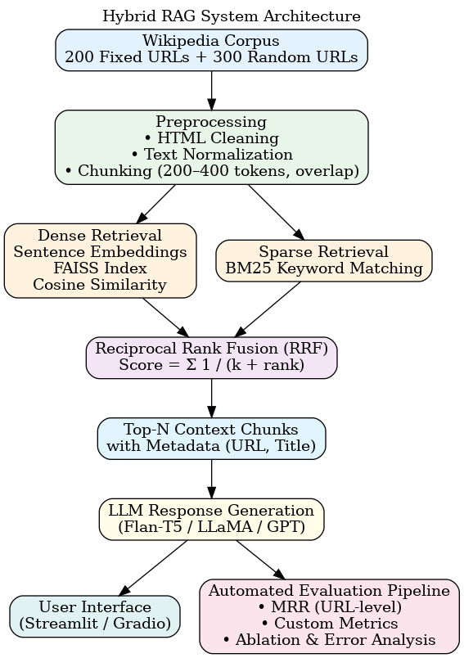
The architecture is modular, allowing independent experimentation with retrieval strategies, ranking methods, and evaluation metrics.
4. Hybrid Retrieval Methodology
4.1 Dense Vector Retrieval
We employ a sentence-transformer model to embed text chunks into dense vector representations. These embeddings are indexed using FAISS for efficient similarity search. Given a user query, its embedding is computed and cosine similarity is used to retrieve the top-K most relevant chunks.
4.2 Sparse Keyword Retrieval
Sparse retrieval is implemented using the BM25 algorithm. Tokenized chunks form the BM25 index, enabling keyword-based matching. This method excels at exact term matching and rare keyword retrieval.
4.3 Reciprocal Rank Fusion (RRF)
To combine dense and sparse retrieval results, Reciprocal Rank Fusion (RRF) is applied. For each retrieved document d, the RRF score is computed as:
RRF(d) = Σ 1 / (k + rank_i(d))
where rank_i(d) is the rank of document d in retrieval method i, and k is a constant set to 60. Documents with higher combined relevance across retrieval methods receive higher scores.
The top-N documents based on RRF scores are selected to form the final context.

5. Response Generation
After hybrid retrieval and ranking using Reciprocal Rank Fusion (RRF), the top-N
most relevant text chunks are selected to construct the final context for answer
generation. These chunks are concatenated along with the user query and passed
to an open-source language model.
We use a lightweight instruction-following LLM (e.g., Flan-T5-base / DistilGPT2 /
LLaMA-based model) to generate responses constrained to the retrieved context.
This approach ensures factual grounding and minimizes hallucinations by limiting
generation to retrieved evidence.
The generation process respects the maximum context length of the model.
Response latency is recorded for each query to support efficiency evaluation.
6. Automated Evaluation Framework
To ensure reproducible and scalable evaluation, we design a fully automated
evaluation pipeline. The pipeline executes the complete RAG process for a fixed
set of 100 evaluation questions and computes retrieval and answer quality metrics
without manual intervention.

The evaluation pipeline performs the following steps:
1. Load the pre-generated evaluation question set
2. Run hybrid retrieval and response generation for each question
3. Record retrieved URLs, generated answers, and response times
4. Compute mandatory and custom evaluation metrics
5. Store results in structured CSV/JSON formats
6. Generate summary tables and visualizations for reporting

The entire pipeline can be executed using a single command, ensuring consistency
across experimental runs.
Code Structure:
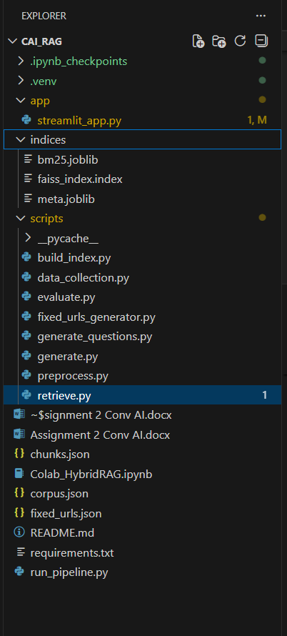
Errors Faced:
In osha lab we were facing memory issues while creating a new environment and installing libraries, due to ml_
env virtual environment.
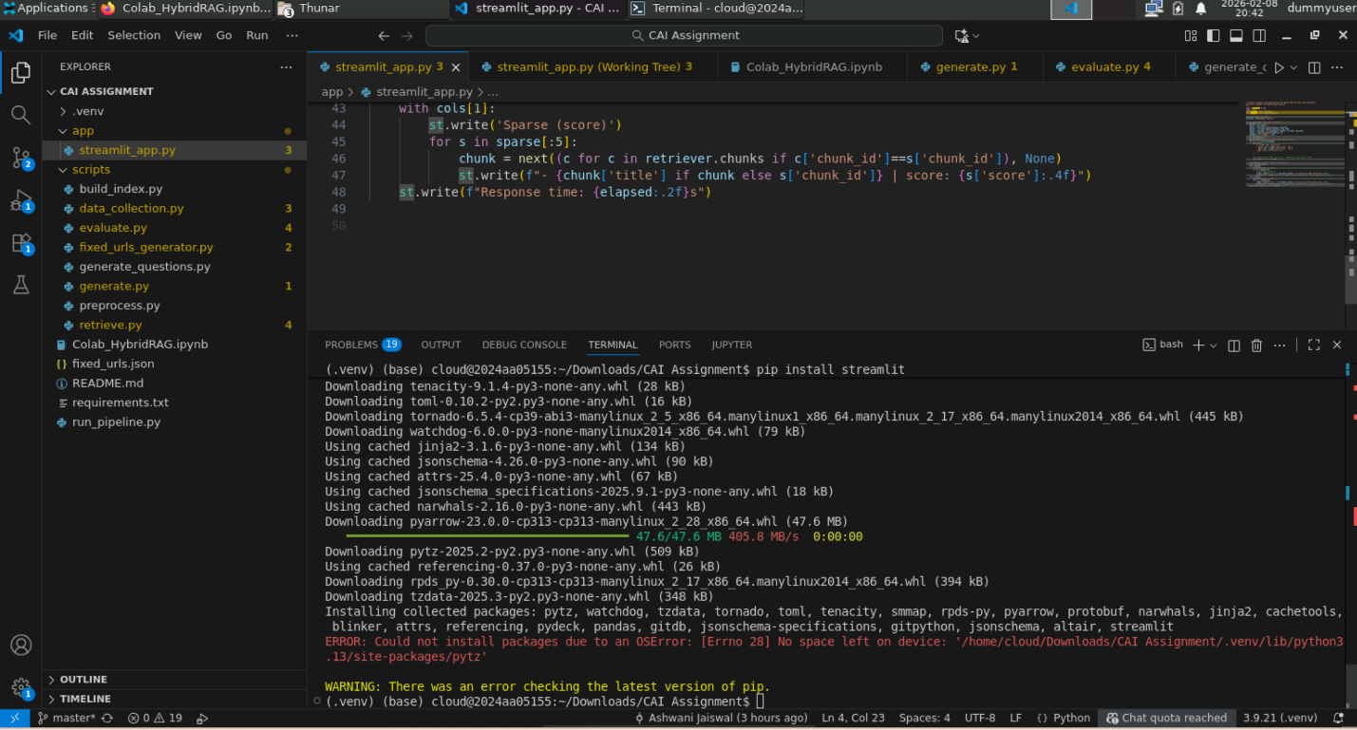
Local System Errors:
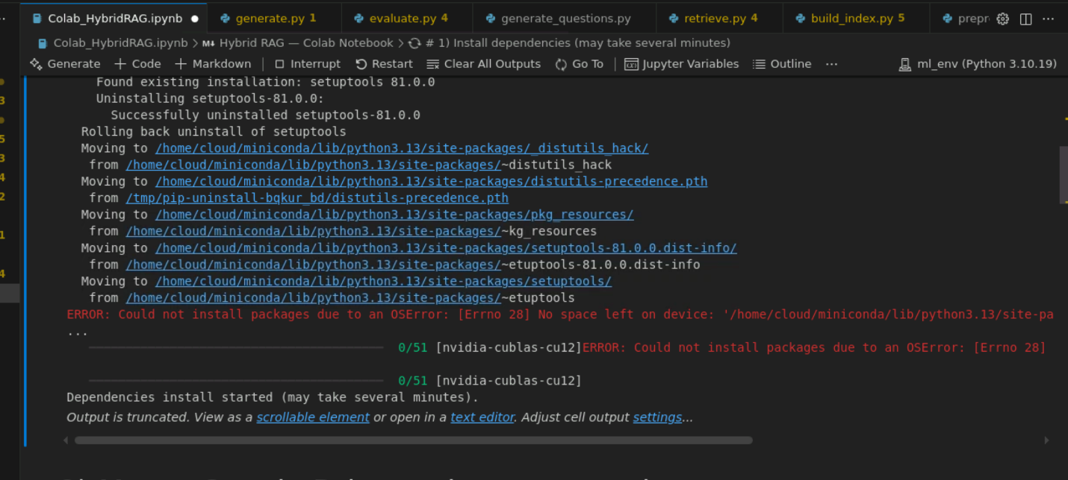
We randomly also were not able to fetch random wiki pages and it was throwing error.

Running Streamlit Application:
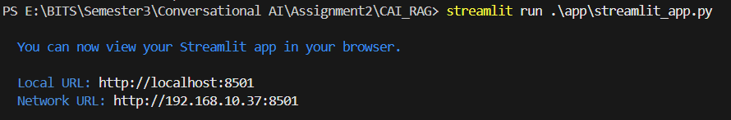
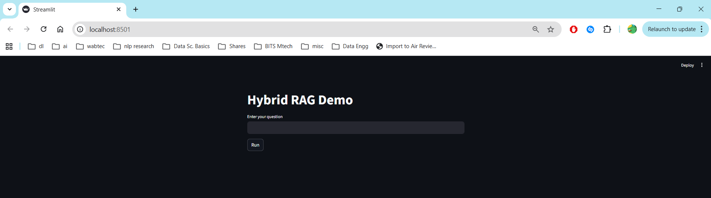
After running a query:
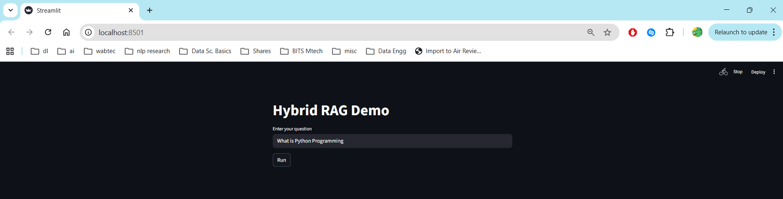
Output below shows it is running flan-t5-base model:
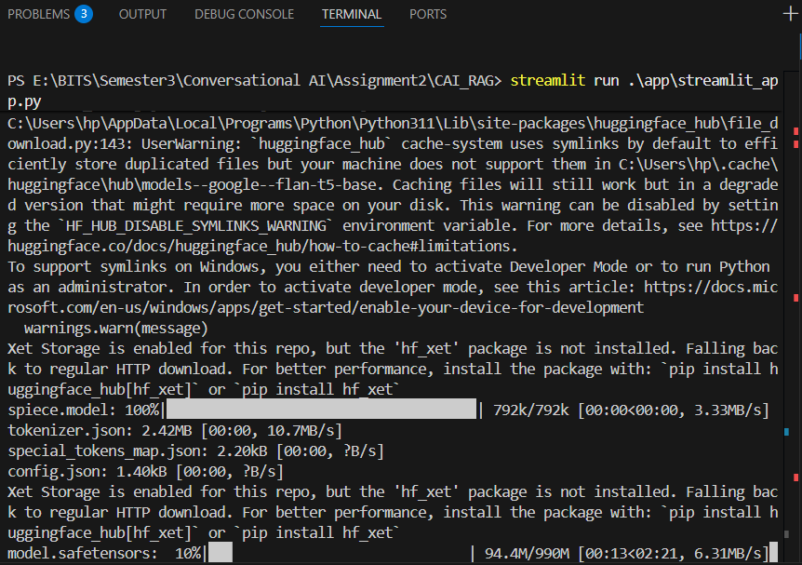
Output after completion:
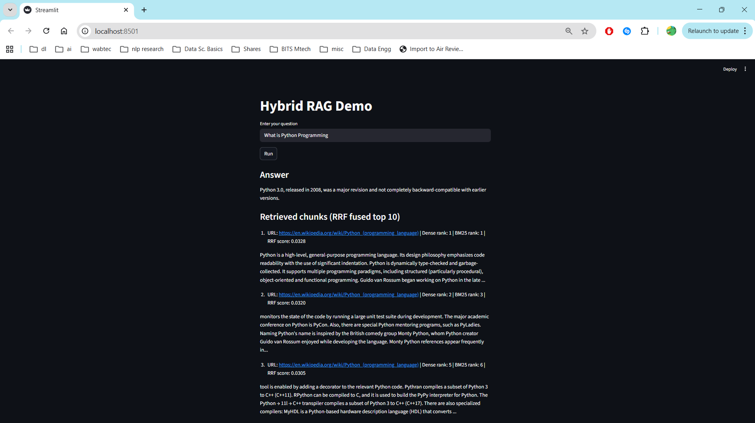

To recreate above Streamlit Application:
Run command:
1. streamlit run ./app/streamlit_app.py
2. This will give url localhost:8501
3. Run it in the browser.
Running colab_HybridRag.ipynb code:
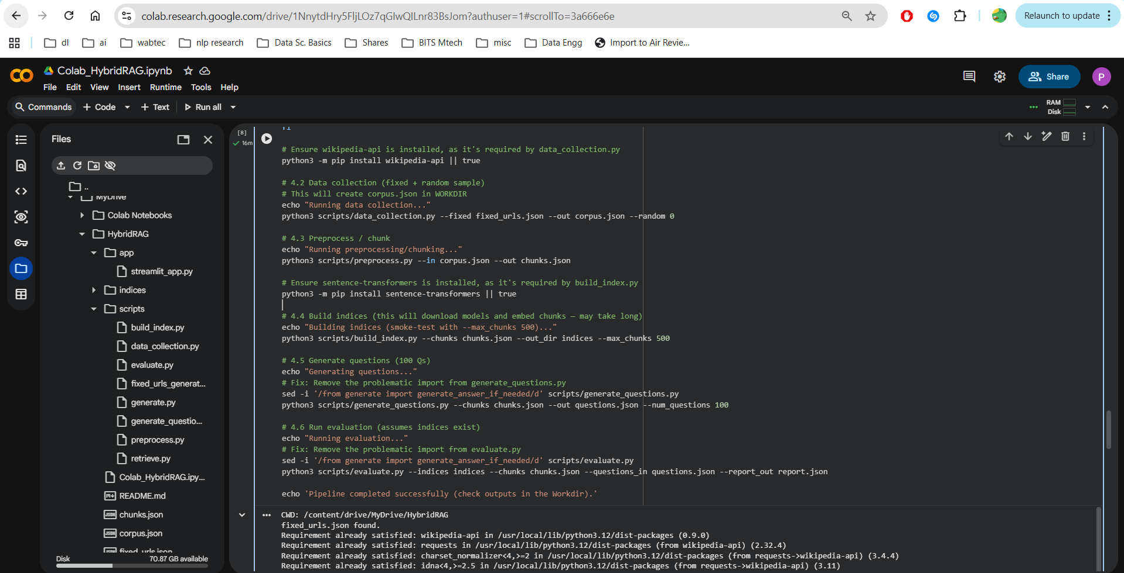

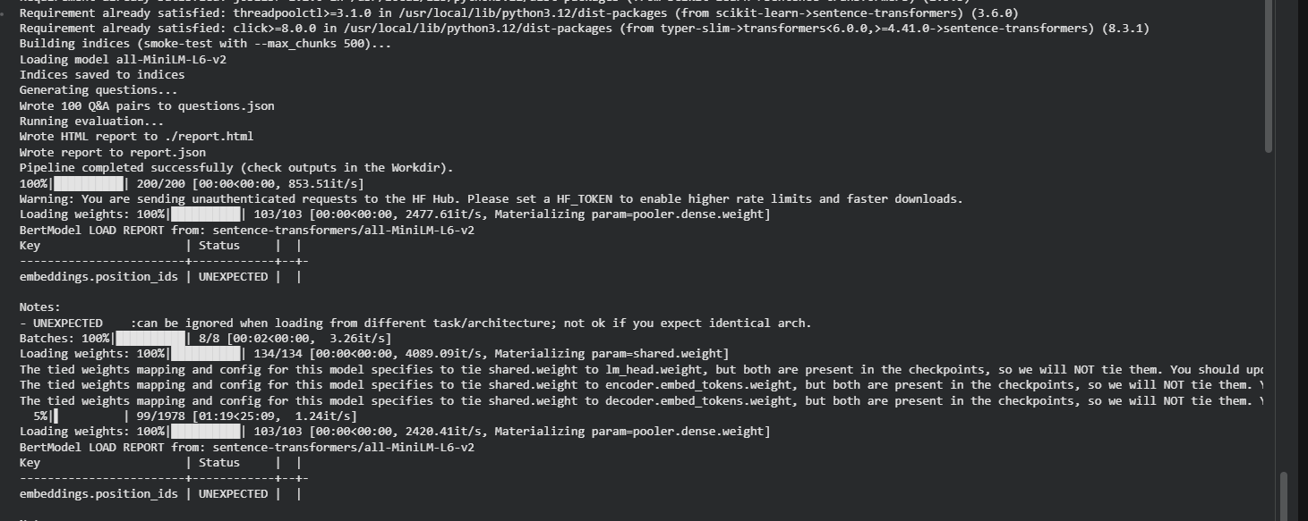
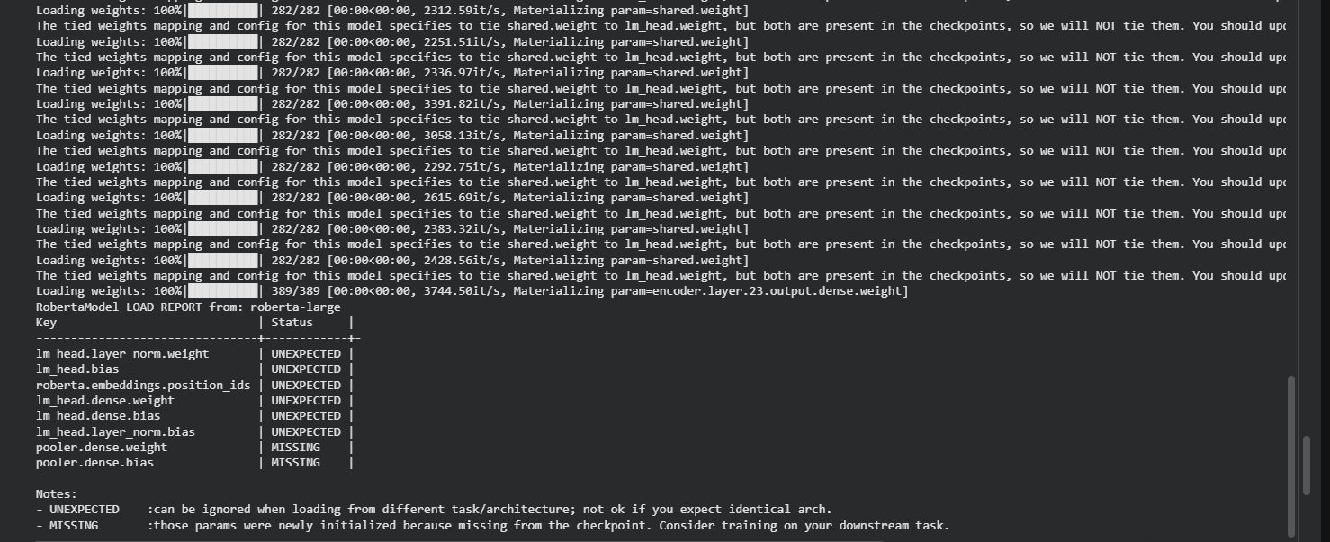
This script runs all the scripts present inside scripts folder which in turn creates indices, runs models does evaluations, stores in db etc.

Evaluation:
Questions.json:
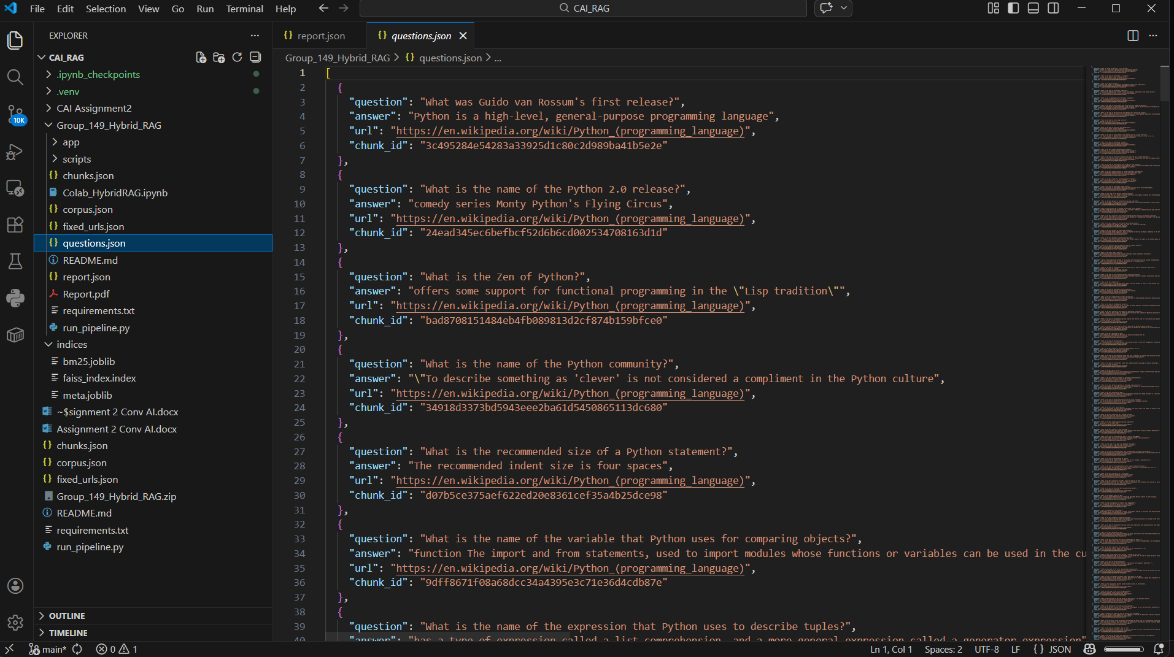
Report.json:
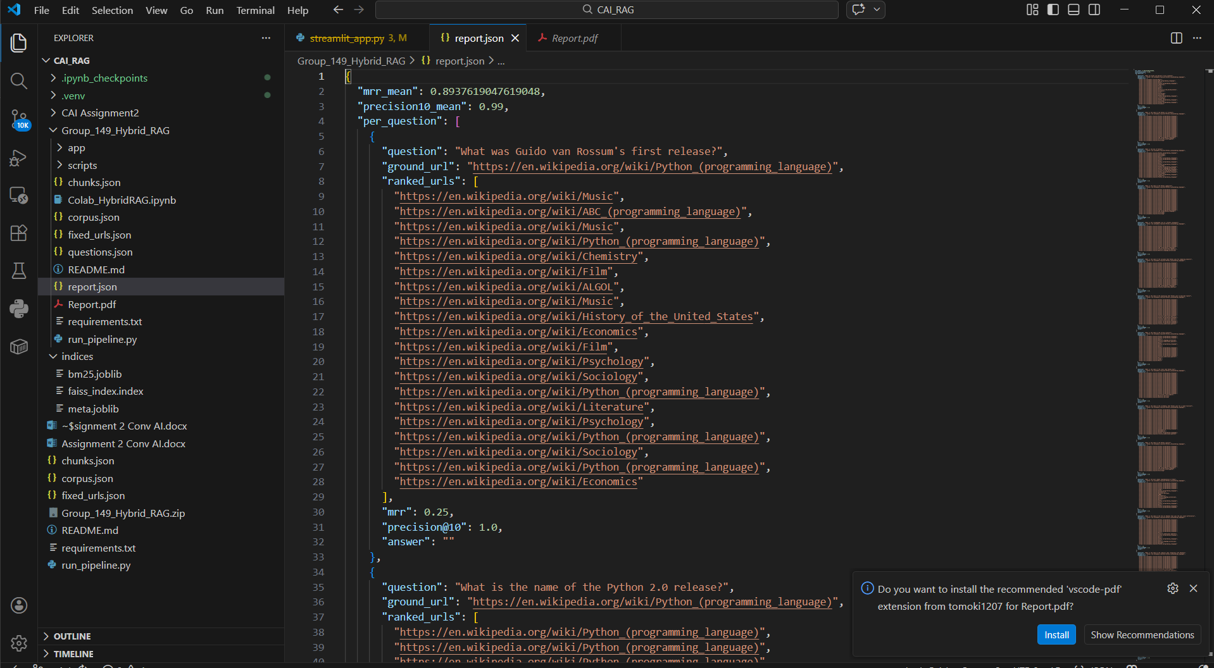
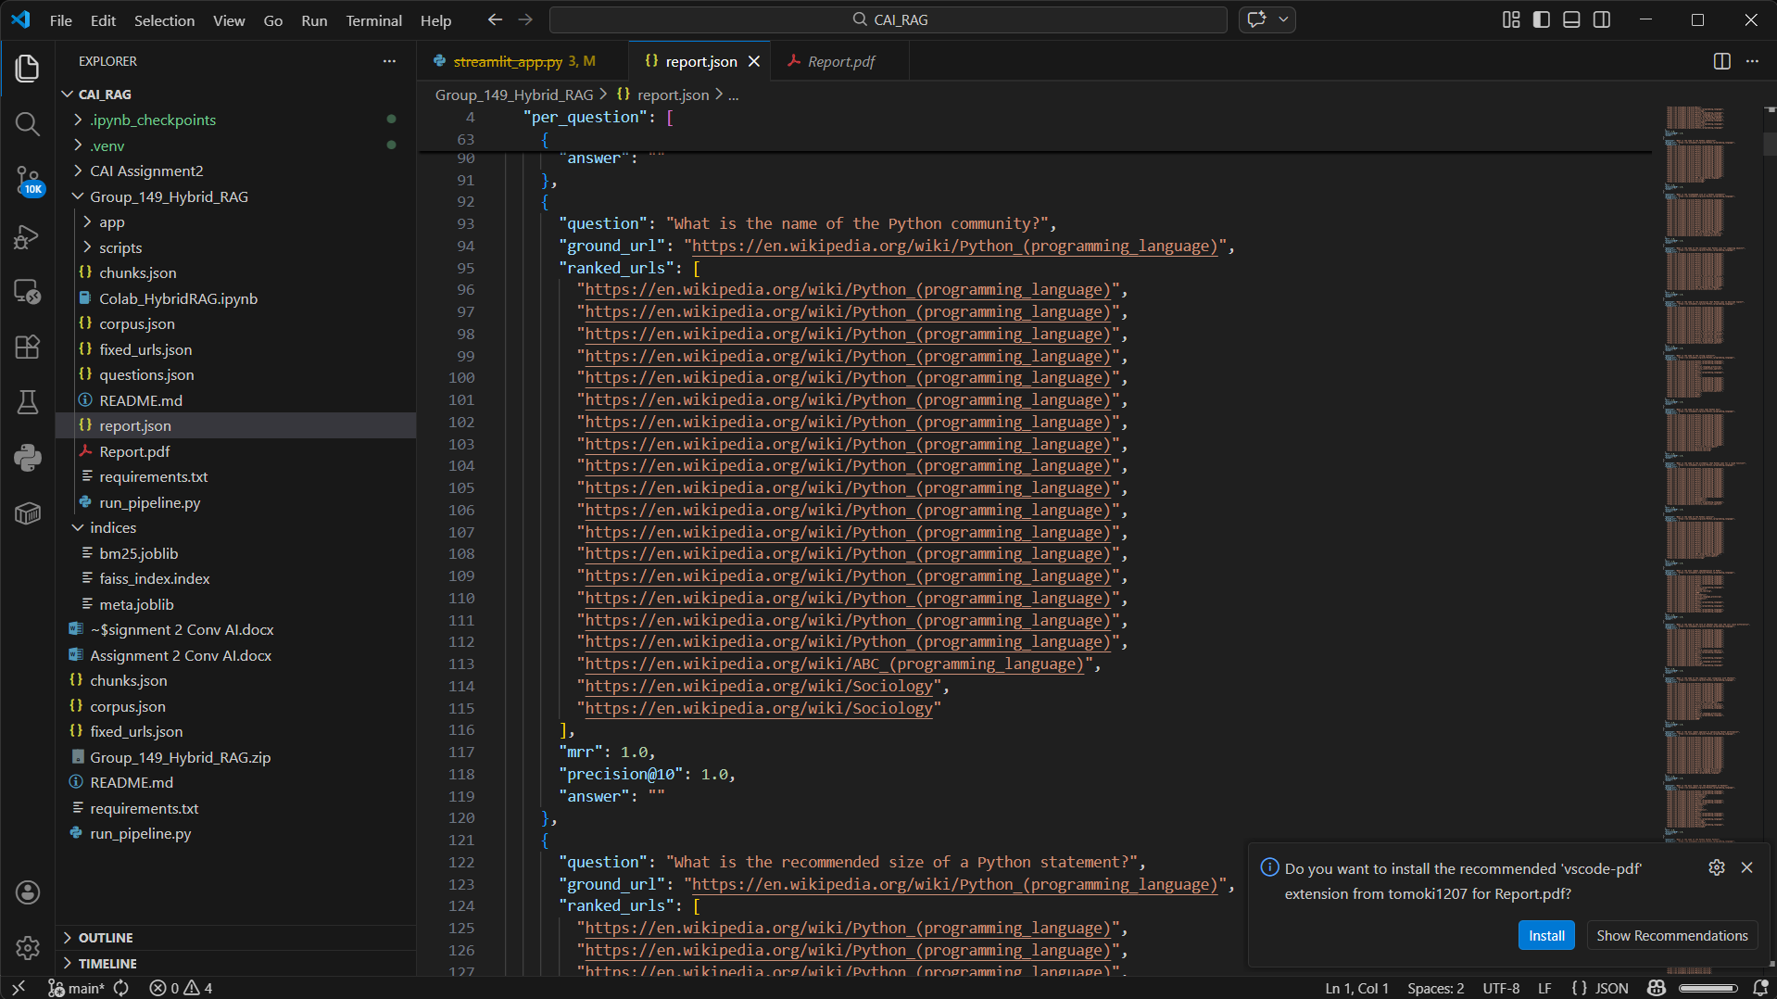

Evaluation Metrics is also shown in reports.html

